Equal (Congruent) Line Segments
# Source: AI Source: Provided by: [Data Path: Persons Table -> ID Column: 1, Name_En Column: Motasem Essam] -> From: [ChatGPT] on [7/25/2026]
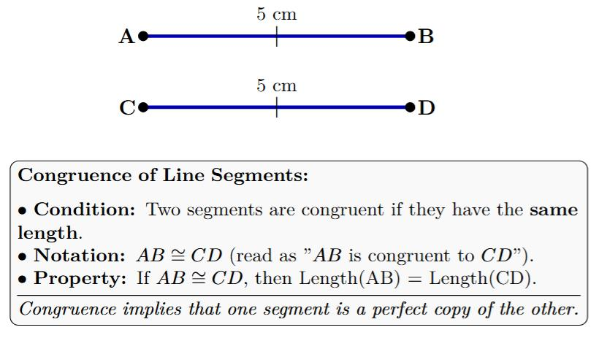

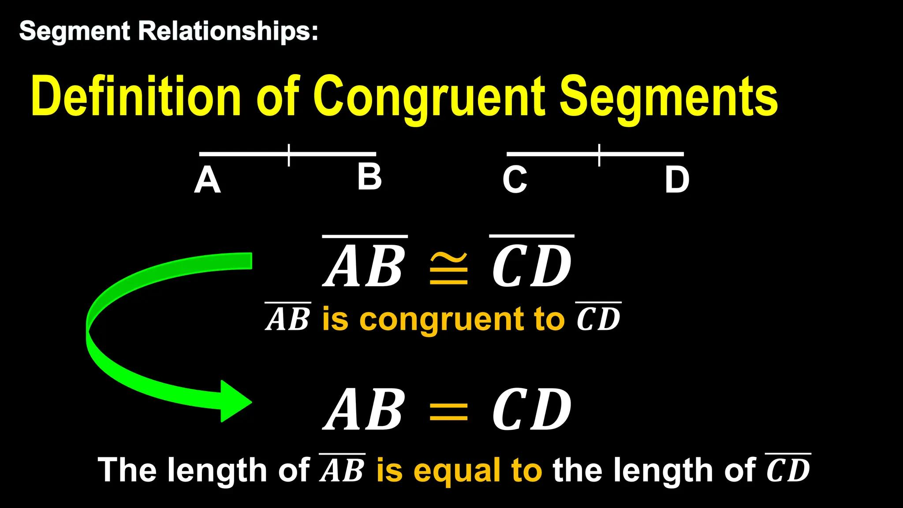
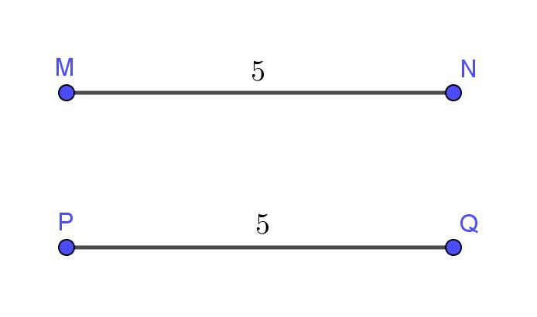
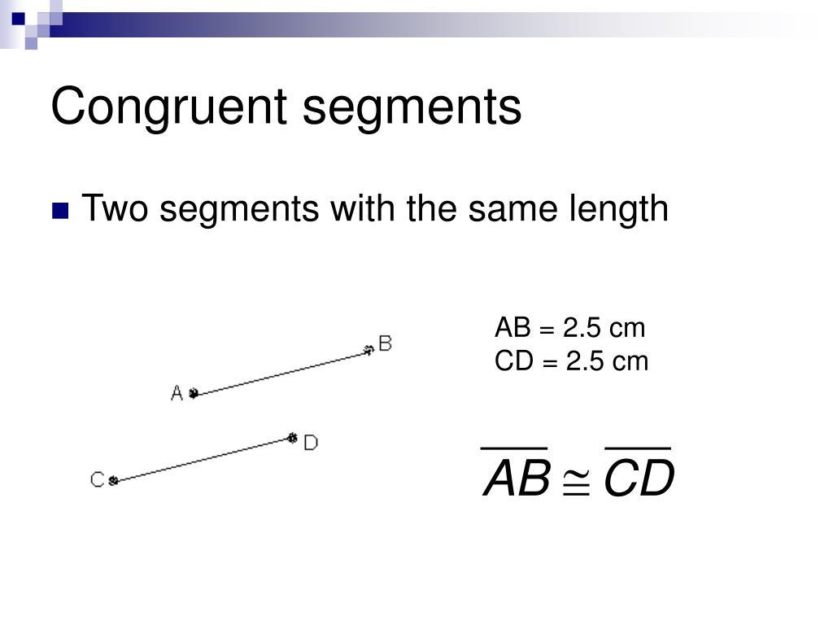
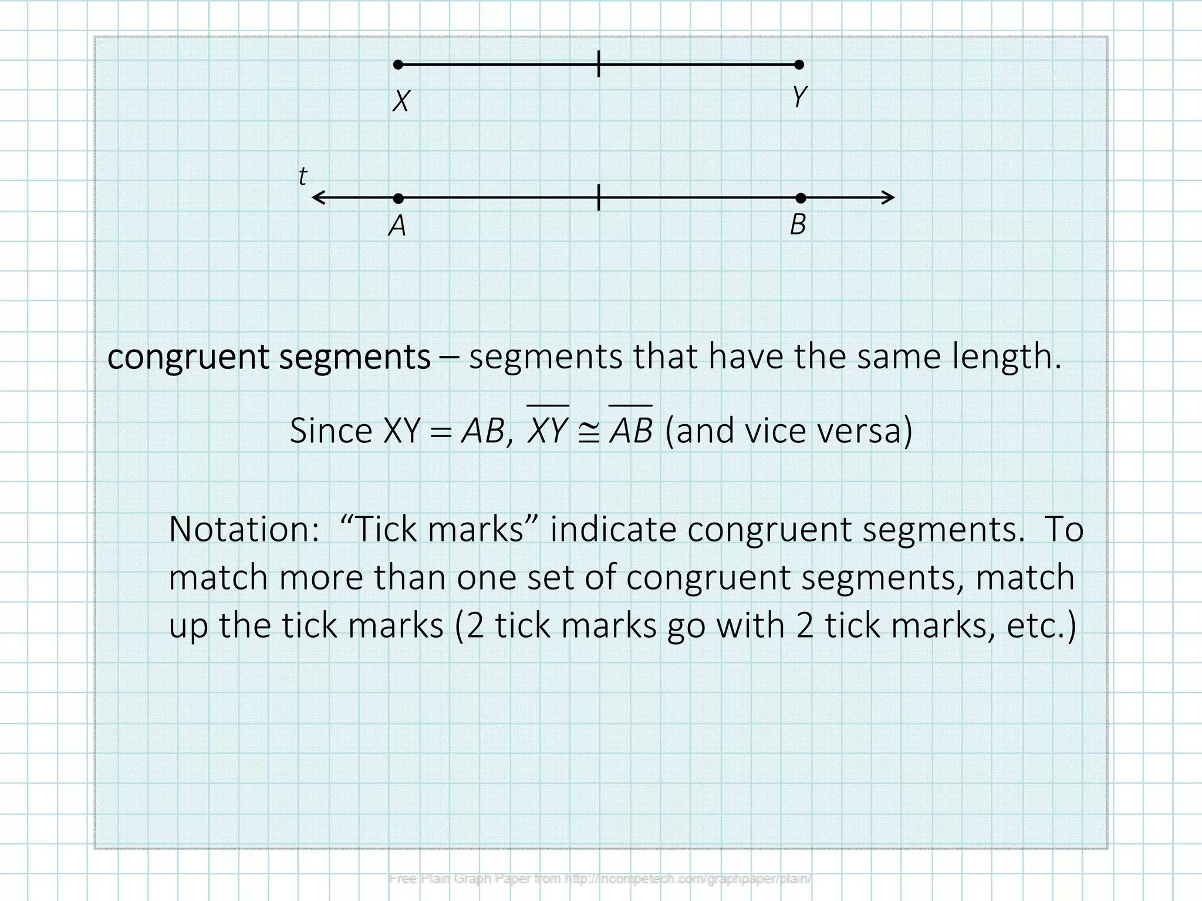

Definition
# Source: AI Source: Provided by: [Data Path: Persons Table -> ID Column: 1, Name_En Column: Motasem Essam] -> From: [ChatGPT] on [7/25/2026]
Equal Line Segments, also called Congruent Line Segments, are two or more line segments that have exactly the same length, regardless of their position or orientation.
They may be horizontal, vertical, or oblique, but as long as their lengths are equal, they are considered congruent.

Characteristics
# Source: AI Source: Provided by: [Data Path: Persons Table -> ID Column: 1, Name_En Column: Motasem Essam] -> From: [ChatGPT] on [7/25/2026]
Equal (Congruent) line segments:
- Have the same length.
- May have different positions.
- May have different orientations.
- May or may not be parallel.
- Are represented using congruence marks in geometric diagrams.

Illustration
# Source: AI Source: Provided by: [Data Path: Persons Table -> ID Column: 1, Name_En Column: Motasem Essam] -> From: [ChatGPT] on [7/25/2026]
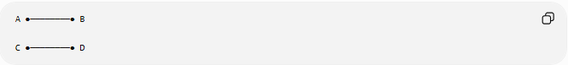
A ●────────● B

C ●────────● D
Both line segments have the same length.

Congruence Notation
# Source: AI Source: Provided by: [Data Path: Persons Table -> ID Column: 1, Name_En Column: Motasem Essam] -> From: [ChatGPT] on [7/25/2026]
Equal line segments are written as:
$$\overset{‾}{AB}≅\overset{‾}{CD}$$
where:
- $\overset{‾}{AB}$and $\overset{‾}{CD}$have equal lengths.

Mathematical Representation
# Source: AI Source: Provided by: [Data Path: Persons Table -> ID Column: 1, Name_En Column: Motasem Essam] -> From: [ChatGPT] on [7/25/2026]
If
$$AB=CD$$
then
$$\overset{‾}{AB}≅\overset{‾}{CD}$$

Coordinate Geometry
# Source: AI Source: Provided by: [Data Path: Persons Table -> ID Column: 1, Name_En Column: Motasem Essam] -> From: [ChatGPT] on [7/25/2026]
Suppose
$$A\left(x_{1} , y_{1}\right), B\left(x_{2} , y_{2}\right)$$
and
$$C\left(x_{3} , y_{3}\right), D\left(x_{4} , y_{4}\right)$$
Then
$$\overset{‾}{AB}≅\overset{‾}{CD}$$
if
$$\sqrt{{\left(x_{2}-x_{1}\right)}^{2}+{\left(y_{2}-y_{1}\right)}^{2}}=\sqrt{{\left(x_{4}-x_{3}\right)}^{2}+{\left(y_{4}-y_{3}\right)}^{2}}$$

Example
Segment 1
$$A\left(1 , 2\right), B\left(5 , 2\right)$$
Length:
$$AB=4$$
Segment 2
$$C\left(3 , 7\right), D\left(7 , 7\right)$$
Length:
$$CD=4$$
Therefore,
$$\overset{‾}{AB}≅\overset{‾}{CD}$$

Congruence Marks
# Source: AI Source: Provided by: [Data Path: Persons Table -> ID Column: 1, Name_En Column: Motasem Essam] -> From: [ChatGPT] on [7/25/2026]
Equal line segments are often indicated using identical tick marks.
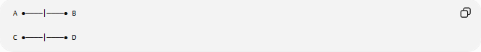
A ●────|────● B

C ●────|────● D
The matching tick marks indicate that the segments are congruent.

Examples
# Source: AI Source: Provided by: [Data Path: Persons Table -> ID Column: 1, Name_En Column: Motasem Essam] -> From: [ChatGPT] on [7/25/2026]
Examples of equal line segments include:
- Opposite sides of a rectangle.
- All four sides of a square.
- The equal sides of an isosceles triangle.
- Matching edges of identical objects.

Properties
# Source: AI Source: Provided by: [Data Path: Persons Table -> ID Column: 1, Name_En Column: Motasem Essam] -> From: [ChatGPT] on [7/25/2026]
Equal (Congruent) line segments:
- Have identical lengths.
- Need not have the same direction.
- Need not be parallel.
- May be located anywhere in the plane.
- Remain congruent after translation, rotation, or reflection.

Applications
# Source: AI Source: Provided by: [Data Path: Persons Table -> ID Column: 1, Name_En Column: Motasem Essam] -> From: [ChatGPT] on [7/25/2026]
Equal line segments are used in:
- Plane Geometry
- Coordinate Geometry
- Engineering
- Architecture
- Construction
- CAD (Computer-Aided Design)
- Technical Drawing
- Surveying
- Computer Graphics
- Robotics

Advantages
# Source: AI Source: Provided by: [Data Path: Persons Table -> ID Column: 1, Name_En Column: Motasem Essam] -> From: [ChatGPT] on [7/25/2026]
Studying congruent line segments helps to:
- Construct accurate geometric figures.
- Prove geometric theorems.
- Analyze symmetry.
- Design engineering structures.
- Create precise technical drawings.

Limitations
# Source: AI Source: Provided by: [Data Path: Persons Table -> ID Column: 1, Name_En Column: Motasem Essam] -> From: [ChatGPT] on [7/25/2026]
Equal line segments:
- Indicate only equal length.
- Do not imply equal direction or parallelism.
- Do not imply the segments lie on the same line.

Comparison with Related Objects
# Source: AI Source: Provided by: [Data Path: Persons Table -> ID Column: 1, Name_En Column: Motasem Essam] -> From: [ChatGPT] on [7/25/2026]
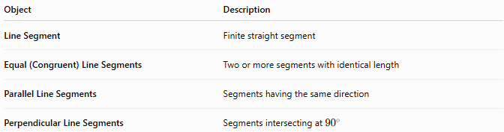
Object | Description
Line Segment | Finite straight segment
Equal (Congruent) Line Segments | Two or more segments with identical length
Parallel Line Segments | Segments having the same direction
Perpendicular Line Segments | Segments intersecting at ${90}^{∘}$

Key Points
# Source: AI Source: Provided by: [Data Path: Persons Table -> ID Column: 1, Name_En Column: Motasem Essam] -> From: [ChatGPT] on [7/25/2026]
- Equal (Congruent) Line Segments have the same length.
- They are represented by:
$$\overset{‾}{AB}≅\overset{‾}{CD}$$
- They may have different positions and orientations.
- Congruence is determined by equal length only.
- Equal line segments are fundamental in geometry, engineering, architecture, CAD, surveying, and technical drawing.

Conclusion
# Source: AI Source: Provided by: [Data Path: Persons Table -> ID Column: 1, Name_En Column: Motasem Essam] -> From: [ChatGPT] on [7/25/2026]
Equal (Congruent) Line Segments are line segments that have exactly the same length, regardless of where they are located or how they are oriented. Congruence is based solely on length and is commonly indicated using identical tick marks or the symbol $≅$. Equal line segments are fundamental in plane geometry, coordinate geometry, engineering, architecture, construction, surveying, CAD, technical drawing, robotics, and computer graphics, where they are essential for constructing accurate geometric figures, proving theorems, and designing symmetrical and precise structures.

